[**SETTING HYPERLINK**](https://careereducation.smartinternz.com/Student/guided_project_workspace/38367#collapse1)

[**"https://careereducation.smartinternz.com/S tudent/guided_project_workspace/38367#co llapse1" HYPERLINK**](https://careereducation.smartinternz.com/Student/guided_project_workspace/38367#collapse1)

[**"https://careereducation.smartinternz.com**](https://careereducation.smartinternz.com/Student/guided_project_workspace/38367#collapse1)

[**/Student/guided_project_workspace/3836 7#collapse1"UP HYPERLINK**](https://careereducation.smartinternz.com/Student/guided_project_workspace/38367#collapse1)

[**"https://careereducation.smartinternz.com/**](https://careereducation.smartinternz.com/Student/guided_project_workspace/38367#collapse1)

[**Student/guided_project_workspace/38367# collapse1" HYPERLINK**](https://careereducation.smartinternz.com/Student/guided_project_workspace/38367#collapse1)

[**"https://careereducation.smartinternz.com**](https://careereducation.smartinternz.com/Student/guided_project_workspace/38367#collapse1)

[**/Student/guided_project_workspace/3836**](https://careereducation.smartinternz.com/Student/guided_project_workspace/38367#collapse1)

[**7#collapse1"APPLICATION HYPERLINK**](https://careereducation.smartinternz.com/Student/guided_project_workspace/38367#collapse1)

[**"https://careereducation.smartinternz.com/**](https://careereducation.smartinternz.com/Student/guided_project_workspace/38367#collapse1)

[**Student/guided_project_workspace/38367# collapse1" HYPERLINK**](https://careereducation.smartinternz.com/Student/guided_project_workspace/38367#collapse1)

[**"https://careereducation.smartinternz.com**](https://careereducation.smartinternz.com/Student/guided_project_workspace/38367#collapse1)

[**/Student/guided_project_workspace/3836**](https://careereducation.smartinternz.com/Student/guided_project_workspace/38367#collapse1)

[**7#collapse1"ENVIRONMENT**](https://careereducation.smartinternz.com/Student/guided_project_workspace/38367#collapse1)

Create IBM Cloud Account

|  |
| --- |
| Date: 2nd Nov 2022 |
| Team ID: PNT2022TMID27677 |
| Project Name: Smart Fashion Recommender Application |

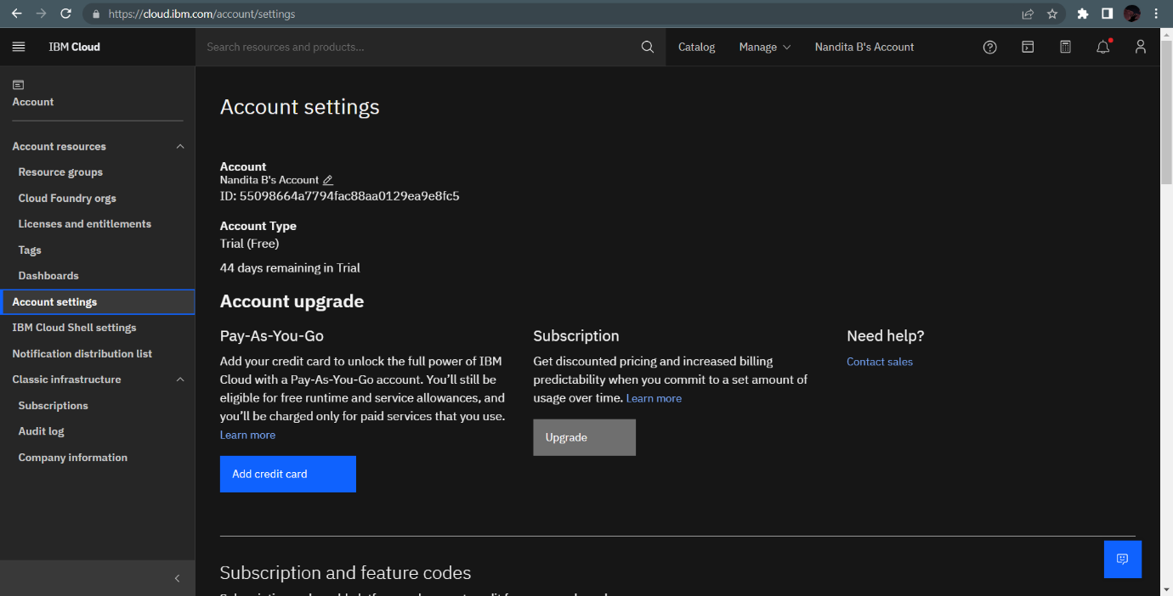IBM Cloud Account has been created.